Implement the following using the SOILD design principles:

To complete the following project, you can use backend database or text file to store and access data.

Form 1 - **Login Form**: Validate and Login a User for Car Selection Application (if user not registered click on registration button to open form 2 otherwise go to form 3)

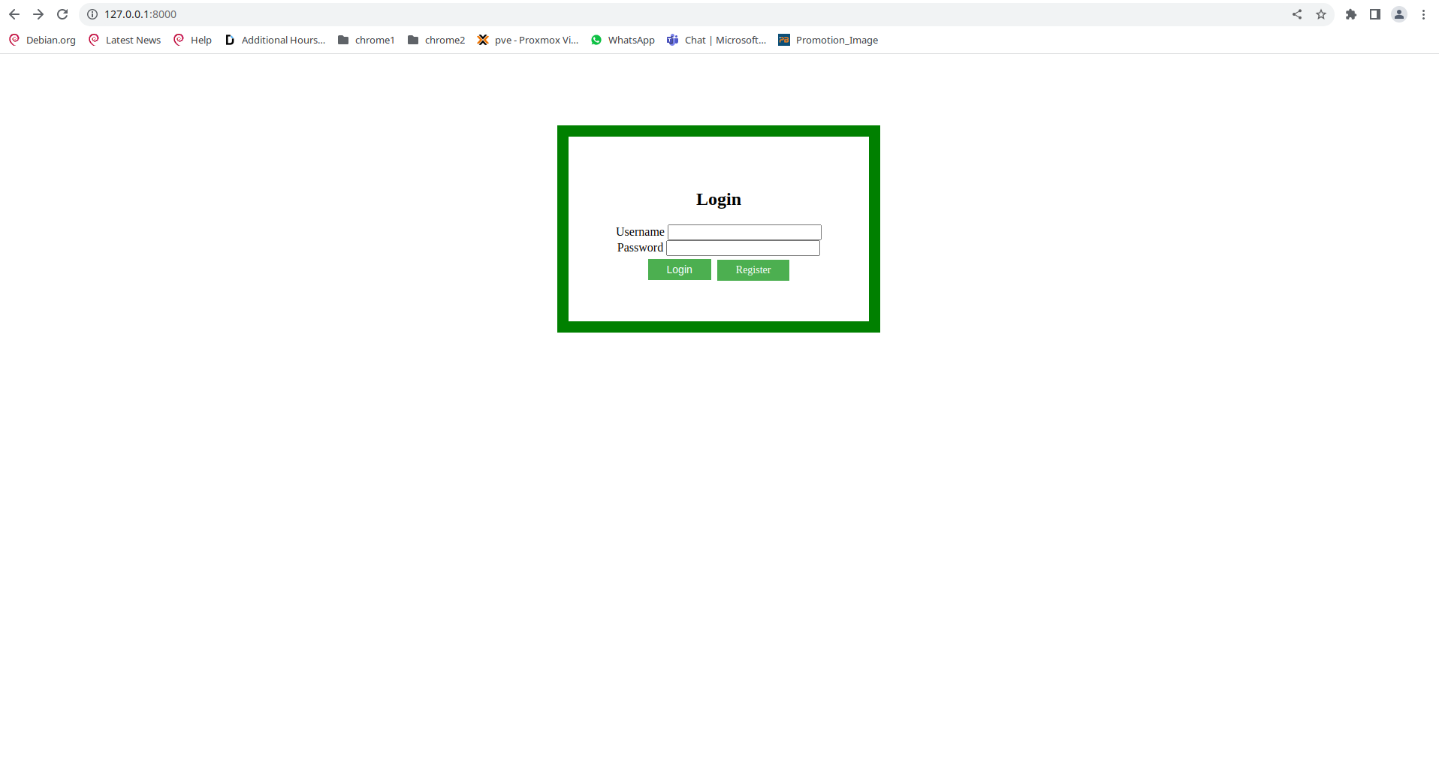

Form 2 - **Registration Form**: Ask User to Enter Details (Name, DoB, Address, Country of Origin) (go to form 3 after registration)

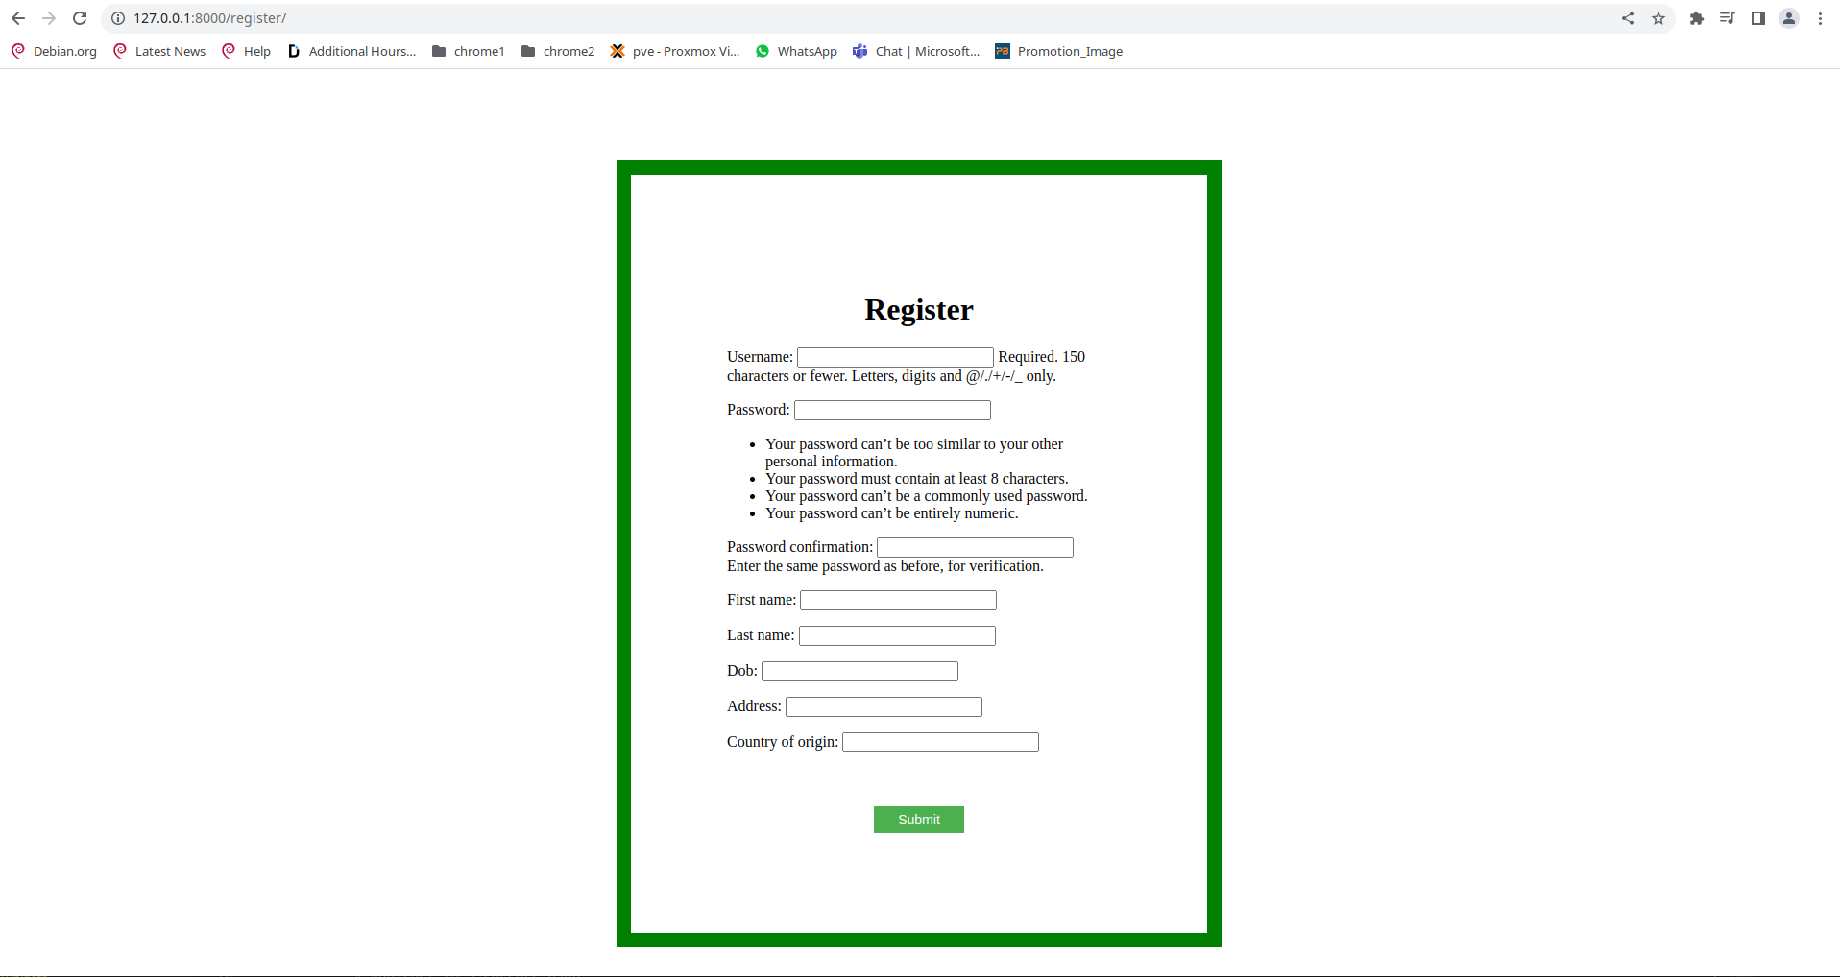

Form 3 - **Home Page**: Display the available cars (car details and button below saying "select")

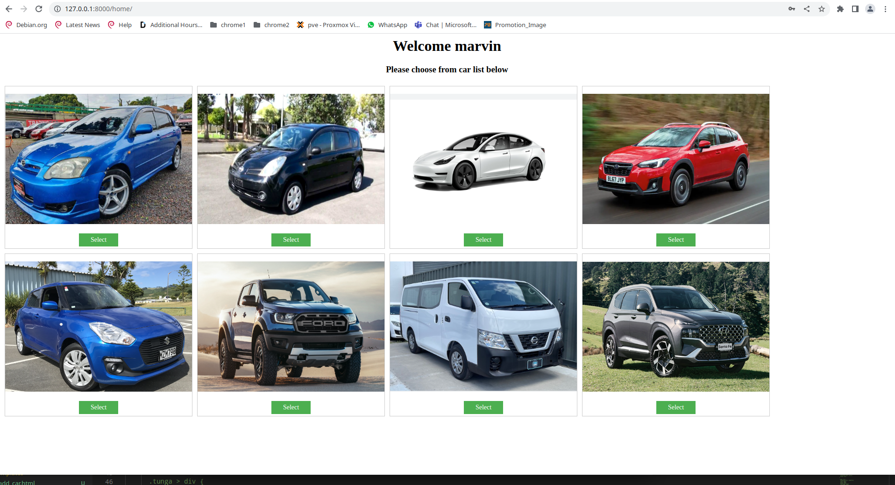

Form 4: Once the User Selects One of the cars display that car name and details on the last form.

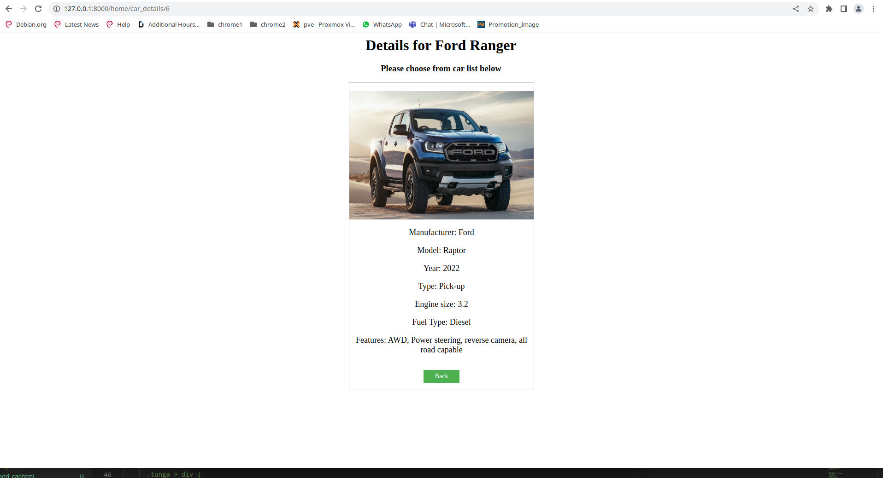

Source code:

https://github.com/marvin-c/W4_D5.git

Created on Python and Django